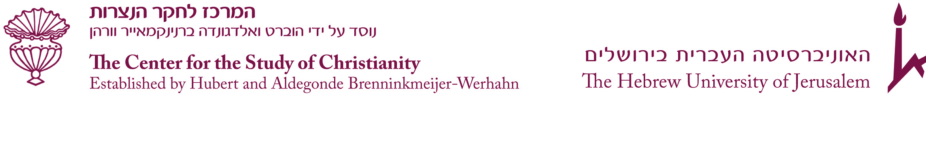

Postdoctoral Research Fellowship 2022-2023
The Center for the Study of Christianity at the Hebrew University of Jerusalem invites applications for two postdoctoral research fellowships in the following areas of study:
- New Testament, Early Christianity, its literature and Jewish context.
- Eastern Christianities.
- Christianity in Palestine/Eretz-Israel (in all fields and throughout its entire history).
- Jewish-Christian relations.

What the CSC is offering:
- The successful candidate will be awarded for one year, beginning on 1 November 2022, a grant of $2000 per month (opening of the academic year: 23 October 2022).
- Travel expenses.
- Library privileges at the Hebrew University.

The postdoctoral fellow is expected to pursue her/his own research and publications, and to participate in the ongoing academic activities of the CSC. The fellow will be expected to deliver one or two lectures about her/his own research, and to be present at the Hebrew University for the duration of the fellowship. The fellowship requires residence in Jerusalem.
Candidates should have received their Ph.D. degree after 1 October 2017 from an institution other than the Hebrew University, and the dissertation approved no later than the application deadline.

Applications:
- A letter of interest including an indication of the other institutes to which she/he have applied (maximum of 500 words)
- Curriculum vitae
- A list of publications
- A research project description (maximum of 1000 words)
- Two letters of recommendation (one from her/his Ph.D. supervisor)
- An official copy of her/his Ph.D. degree certificate or Ph.D. submission

All application materials must be submitted via the Hebrew University’s Scholarships and Awards System (http://scholarships.huji.ac.il). The letters of recommendation should be sent directly by the evaluators, according to the guidelines specified in the online application system. Only once we receive the letters of reference will the application be considered.

Deadline for applications: 25 July 2022. A decision will be announced by 10 August 2022.

Should you have any queries or require further information you may contact us at: csc@mail.huji.ac.il

